Guidelines for Counting **Virtual Programming Statistics**

for the Indiana State Library Annual Report

* Track the following types of programs **separately**:
  + In-person
    - # of events (at the library vs off-campus)
    - # of people attending
    - Age group of target audience (children, teens, adults, general)
  + Virtual programs – live
    - # of streaming events (Facebook, Zoom, Skype, etc.)
    - # of live views / maximum concurrent live views (depending on platform)
  + Virtual programs – recorded
    - # of library-created content that is posted online for asynchronous patron access
    - # of page views/hits
* When counting hits on virtual programs – recorded, please count for either as long as the video is posted, OR until the end of the calendar year (Dec 31, 2020) – whichever is sooner.
* For a program that is originally livestreamed, but later archived:
  + Count it as one virtual program – live/streaming.
  + Count the live views during the stream.
  + Do NOT count it as another program once it is posted online.
  + DO count the hits/views on the program. These will be added the hits to your total “recorded programs – page views” number on the annual report.

*see second page for a visual representation of how to count virtual programming

Sample programming statistics:

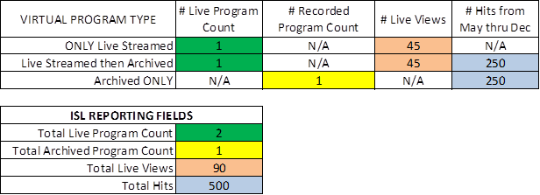

*table created by Garrett Mason at IndyPL and used with permission