**Registering your state-issued device with Ivanti - MobileIron Go**

1. **Swipe up to get started.**

**Select English Select United States**

1. **Click on Set Up Manually**

1. **Select Use Cellular Connection**

1. **If "Use Cellular Connection" is not available, click on Indiana Public Wifi (you will be directed to the User Agreement screen. Click on Accept and Done**

1. **Click on Continue on the Data & Privacy screen.**

1. **Click on Next on the Remote Management Screen.**

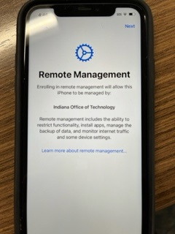

1. **Enter your Email address and click on Continue. Select Company owns this device.**

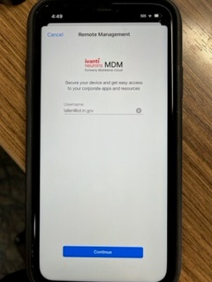 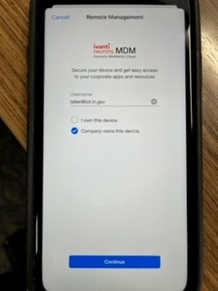



1. **You will be prompted to sign in with your Email and Network password to authenticate.**

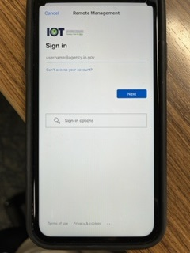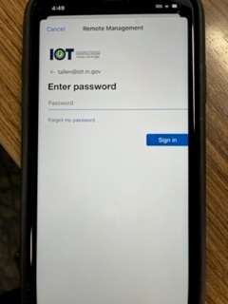

1. **Create a passcode for the device. (It cannot be the same number - ascending or descending).**

1. **Click on Continue to keep the iPhone up to date.**

1. **Enable Location Services and click on Get Started.**

1. **The MobileIron Go app, Apps@Work, Microsoft Teams and the Authenticator app will automatically load to the device.**

1. **Click on the MobileIron Go app and click Allow.**

1. **You will then be prompted to update your Exchange account. Click on Edit Settings.**

1. **You will be prompted to Authenticate, then click on Work or School Account.** Graphical user interface, text, application

   Description automatically generated



1. **The Exchange account will show what it will sync. Click on MobileIron Go on the top left.**



1. **In Setup, register your device on the Microsoft Office 365 compliance screen. Click Continue.**

1. **Click Open and choose your account.**



1. **Enter your password and sign in.**



1. **Your device will finish authenticating and your Device Status will be shown in Compliance.**

**Your device is now registered. You will need to complete the setup for Teams by signing in and authenticating as well.**