<Date>

TO: 0000000 00000000
< Designer Stamp >
INDOT Project Manager
Designer Signature

FROM: 0000000 00000000
Consultant Engineer
<email>
<firm>
QA Signature

THROUGH: 0000000 00000000
INDOT Engineer

This memo is not to be considered final until it has been signed and stamped by the designer and signed by the QA engineer.

SUBJECT: Hydraulic Review
Des. #:
Asset Name: <(Culvert or Bridge Asset ID)>
County:
Location: <(Determined from BIAS or SPMS )>
Crossing: <(stream crossing)>
DNR CIF Permit Required (Y/N): Choose an item.
Legal Drain (Y/N): Choose an item.

Site Parameters
Drainage Area | (Area)
Q₁₀₀ (AEP 1%)Discharge | (discharge) | cfs
QChoose an item. (AEP Choose an item.)Discharge for velocity | (discharge) | cfs
Q₁₀₀ (AEP 1%) Choose an item. Depth | (TW depth) | ft.
US Edge of Travel Lane | (road elev) | ft.
Design Roadway Serviceability Elevation | (serv. elev) | ft.

Culvert Properties
Parameter | Existing |  | Proposal 1 |  | Proposal 2 |  | Proposal 3
Structure Size & Type |  |  |  |  | (delete column if not needed) |  | (delete column if not needed)
Q₁₀₀ Headwater Elevation |  | ft. |  | ft. |  | ft. |  | ft.
QChoose an item. (AEP Choose an item.) Headwater Elevation |  | ft. |  | ft. |  | ft. |  | ft.
Meets Roadway Serviceability @ QChoose an item. (AEP Choose an item.) | Choose an item. |  | Choose an item. |  | Choose an item. |  | Choose an item.
Backwater |  | ft. |  | ft. |  | ft. |  | ft.
Minimal Low Structure Elevation (DS) |  | ft. |  | ft. |  | ft. |  | ft.
Assumed Flowline Elevation (DS) |  | ft. |  | ft. |  | ft. |  | ft.
Sump Depth |  | in. |  | in. |  | in. |  | in.

<<<Discussion of Existing Conditions, Proposals, and Analysis>>>

Please note that if a square edge headwall is required for a replacement structure, then a flared end section may be used at the inlet in place of constructing an actual headwall should the structure type be eligible. If a beveled headwall wall is required, then it must follow the figure below and a headwall constructed.

Riprap Design Recommendations

Riprap Properties
Parameter | Proposal 1 |  | Proposal 2 |  | Proposal 3
Structure Size & Type |  |  | (delete column if not needed) |  | (delete column if not needed)
Outlet Velocity @ Q Choose an item.(AEP Choose an item.) | (vel) | ft/s |  | ft/s |  | ft/s
Outlet Riprap Size | Choose an item. |  | Choose an item. |  | Choose an item.
Inlet Riprap Needed (Y/N) | Choose an item. |  | Choose an item. |  | Choose an item.
Natural Channel Velocity @ Q Choose an item.(AEP Choose an item.) |  |  |  |  |  | ft/s
Minimal Inlet Riprap Size if Warranted | Choose an item.

Outlet riprap based on the size shown in the above table should be placed on geotextiles according to IDM Figure 203-2J. <If applicable please state any standard drawings as well> Choose one: Inlet riprap does not appear to be required based on the site visit. If it is determined necessary by the designer, a minimum size described in the table or larger should be placed according to the designer’s discretion.> or <The minimum size riprap described in the table is required at the inlet due to <give reason>>

Alternative scour protection designs should be submitted to the INDOT Office of Hydraulics for review and approval.

Beveled Edge Headwall Detail

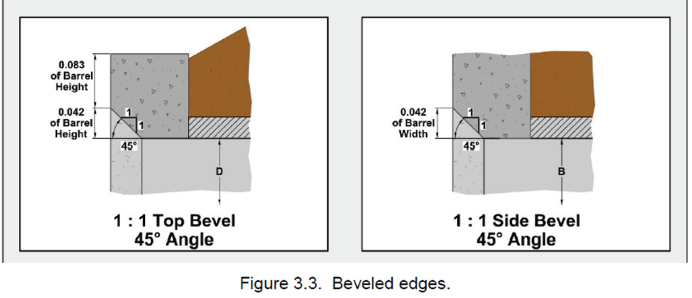

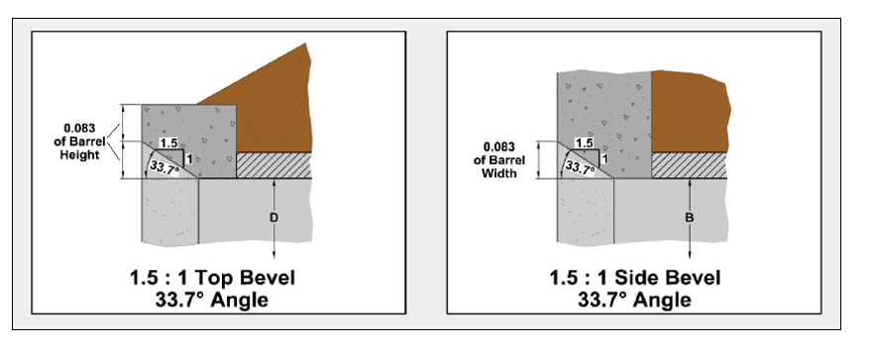

Source: J. D. Schall, Hydraulic design of highway culverts, 3rd ed. Washington, D.C.: U.S. Dept. of Transportation, Federal Highway Administration, 2012. Pg. 3.5, Fig. 3.3

External Energy Dissipater Details – Riprap Basin

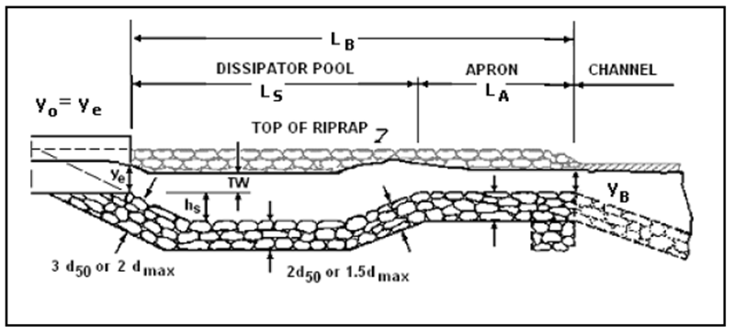
See IDM Figure 203-2K or HEC-14 for more information.

Riprap Basin Properties

 | Option 1 |  | Option 2 |  | Option 3 |  | Option 4
Basin Length (L_{B}) |  | ft. |  | ft. |  | ft. |  | ft.
Basin Width |  | ft. |  | ft. |  | ft. |  | ft.
Apron Length (L_{A}) |  | ft. |  | ft. |  | ft. |  | ft.
Pool Depth (h_{s}) |  | ft. |  | ft. |  | ft. |  | ft.
Riprap Size | Choose an item. |  | Choose an item. |  | Choose an item. |  | Choose an item.

Inlet Depression Details

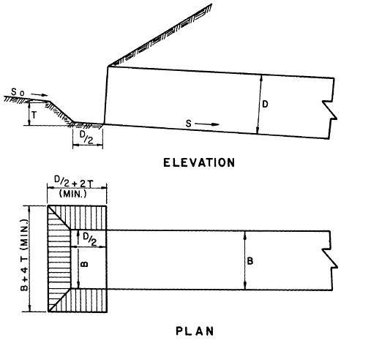
HDS 5 - Figure 3.5 Culvert with Inlet Depression
Riprap should be installed along the depression slopes and at the bottom by the inlet.

Inlet Depression Properties

Parameter | Inlet Depression Properties
Replacement Option | Option #1 |  | Option #2 |  | Option #3 |  | Option #4
T |  | ft |  | ft |  | ft |  | ft
D |  | ft |  | ft |  | ft |  | ft
B |  | ft |  | ft |  | ft |  | ft
D/2 (apron) |  | ft |  | ft |  | ft |  | ft
B + 4T (total width) |  | ft |  | ft |  | ft |  | ft
D/2 + 2T (total length) |  | ft |  | ft |  | ft |  | ft
Total Crest Width |  | ft |  | ft |  | ft |  | ft
Riprap Class | Choose an item. |  | Choose an item. |  | Choose an item. |  | Choose an item.

If you have any questions or comments, please contact me at (317) 23X-XXXX.

cc: file

