INDOT Training Portal Quick Step Guide
Contents
INDOT Training Portal Quick Step Guide 1
Creating a User Account 2
Course Enrollment 2
Starting the Certification Course 3
How to Print or Save a Certificate of Completion 3
Home Page Tiles 4
My Learning Assignments 4
Find Learning 4
My Curricula 4
History 4
Links 4
How to Access my Training History 5
How to Change Information on my User Account 5
Questions or Need Help 5

Creating a User Account
- Go to the INDOT Training Portal
- Select Click here to register
- Fill out Account, Contact, and Employee Information
  - Users are advised not to use their email address as their User ID. User IDs are permanent, so we want to ensure users do not create multiple accounts as their email address changes.
  - User IDs are case sensitive
- Select Submit
- User accounts are reviewed before access is given. You will receive an automated email when you are able to access your account. Example of the email is below:
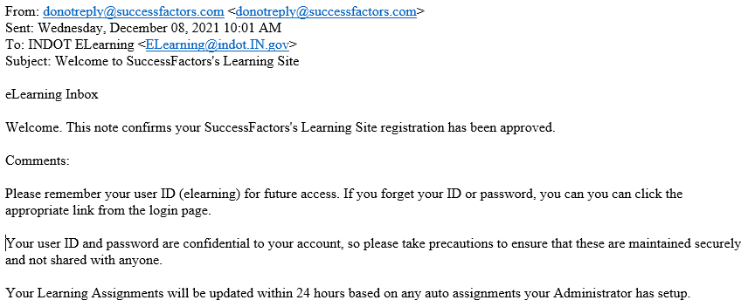
- Accounts created on the weekend or holidays will not be approved until the next business day. If your account has not been approved in 24 hours, please contact ELearning@indot.in.gov .

Course Enrollment
To enroll in one or more of the ERC Certification Courses do the following:
- Send an email to LPAQuestions@indot.in.gov requesting the course you would like to enroll.
  - Include the User ID chosen when creating your account in the INDOT Training Portal.
  - Include the name of the course(s) you are enrolling.
    - ERC Basic Certification
    - ERC Recertification
    - ERC Bridge Inspection Certification

- INDOT LPA staff will enroll you for the course(s), and you will receive an automated email verification stating enrollment is complete. Example of the email is below:
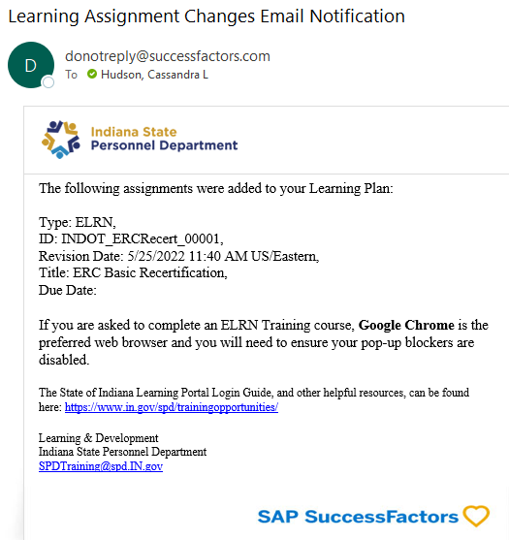

Starting the Certification Course
Start the course by logging into INDOT Training Portal.
- Upon completion of the course, you will be prompted to print the certificate. Instructions on how to print are below.
- Email a copy of your certificate to the District Program Director.

How to Print or Save a Certificate of Completion
- On the My Learning page locate the History tile.
- Select View All
- Find the course under your Completed Work list and select the print button, located under the Action column
- When the certificate opens, select Print or Save at the bottom of the screen and then follow the prompts.

Home Page Tiles
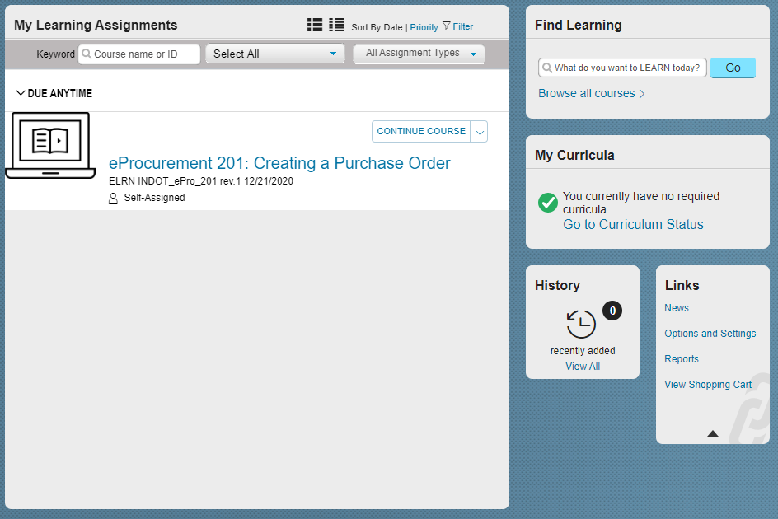

My Learning Assignments
Under My Learning Assignments you can find online, or instructor led training that has been self-assigned or assigned to you. Trainings will remain under this tile until it is complete, or you withdraw from the course.

Find Learning
In the search bar of the Find Learning tile, you can search the training library for online and instructor led training. Once you find the training you are interested in you can start or register for the course.

My Curricula
The My Curricula tile will contain any curriculum you have requested to take. A curriculum is a single course or group of courses that recur over a designated renewal cycle.

History
Under the History tile you can find all training, online and instructor led, completed within the INDOT Training Portal. You can also print completion certificates in this area.

Links

News
This link will open any automated system announcements. These announcements are the same for our internal and external users so not all announcements apply to our external users.

Options and Settings
Under Options and Settings, users can update account security information, learning email notifications, locale and time zone, locale format options, contact, and employee information.

Reports
On the Report page users can pull several reports to review their training requests, status, history, hours, and other information. These reports will only return information about the individuals learning.

View Shopping Cart
View Shopping Cart is where users can review paid items placed in their cart and check out. Payment is not processed through the INDOT Training Portal so you will need to follow the direction under Enroll in a Paid Online or Instructor Led course.

How to Access my Training History
- On the Home page locate the History tile.
- Select View All

How to Change Information on my User Account
- On the Home page locate the Links tile.
- Select Options and Settings
- On the Options and Settings page, you can update your:
  - Security question and answer
  - Email notification preferences
  - Contact information
  - Business Name
- Once information is updated remember to select Apply Changes to update settings.

Questions or Need Help

- Contact ELearning@indot.in.gov for any questions regarding the INDOT Training Portal.

- Contact LPAQuestions@indot.in.gov for questions about course content and to enroll in an ERC Certification Course once you have an INDOT Training Portal User ID.

- Contact your District Program Director with questions about course content or enrollment.

