State Imaging and Microfilm Laboratory
Indiana Archives and Records Administration
100 N. Senate Avenue, Room N055
Indianapolis, IN 46204
317-232-3381
imaging@iara.in.gov

Conversion of Electronic Records to Microfilm
Introduction
Using the SMA 51 Archive Writer, the Indiana Archives and Records Administration is able to offer a fee-based service that enables government agencies and other patrons to convert scanned images or born digital records to archival microfilm for long-term storage and access.
The Indiana Archives and Records Administration offers this service because microfilm processed in accordance with archival standards is a reliable and sustainable medium that can improve the longevity of digital files.

SMA 51 Archive Writer
The SMA 51 converts digital images to 16mm and 35mm microfilm. The machines use high resolution monitors to display images for a camera to capture on film. They are able to accommodate many different requests, including positive images, metadata, and info frames. If there are any special requests such as these, make note when contacting the agency for work or when filling out the Request for Services form (State Form 56676).

Submitting Files for Microfilming
Image Format
- Images must be TIFF or PDF for best results. Agencies using other formats should explore the use of file conversion software if they do not wish to be charged for prepping services.
Roll Format/ Structure
- All batches of images sent should contain an index detailing number of rolls, amount of images per roll, the name of subfolders or files to be written, and the order in which folders or files should be written.
  - If documents are multipage, the index needs to identify their page length
- Letter size and legal size documents will be written to 16mm film.
  - These rolls cannot exceed 2,500 images
- Any images larger than legal size, such as architectural drawings, maps, and newspapers, will be written to 35mm film
  - These rolls cannot exceed 650 images
- Files should be grouped together by record series for better organization and future retrieval.
- When structuring groups of files, files/images should not be put deeper than 1 subfolder. The SMA cannot read files past this depth. For example, the preferred structure is as follows:
  - Record Series 81-241 (Roll 1)
    - Jan-June 2019 (Subfolder 1)
      - File/Image 1
      - File/Image 2
    - July-Dec 2019 (Subfolder 2)
      - File/Image 1
      - File/Image 2
File Naming
- When using numbers as file names, make sure there are a consistent number of characters. An inconsistent number of characters can cause images to be written out of order. For example:
10.tiff
100.tiff
2.tiff
The above images have an inconsistent amount of characters causing the 2.tif to be written last.
002.tiff
010.tiff
100.tiff
These images have three characters each and will write to film in the correct order.

- Non-numerical named images will be written in alphabetical order. If alphabetical order is not desired, a numerical prefix to each file will be required. For example:
    - 002 emails.tiff
    - 010 memos.tiff
    - 100 contracts.tiff
- If there are images with numerical names and non-numerical names, the numerical will write first, followed by the non-numeric in alphabetical order. For example:
    - 002 emails.tiff
    - 010 memos.tiff
    - 100 contracts.tiff
    - expenses.tiff
    - reports.tiff
    - sales.tiff
Image Resolution/ Quality
- Images should have a minimum resolution of 300 dpi. A higher dpi is acceptable but not usually necessary. Our suggestion is for text-only documents to be captured at 300 dpi and documents with images be captured around 400-600 dpi. The resolution of the microfilm is determined by the documents initial scan, as the archive writers can only replicate quality, not improve it.
- If using a scanner to self-produce digital images, agencies should crop any excessive space surrounding the images.
- The quality of the microfilm is controlled at the point of scanning. As a result, all images need to be deskewed as much as possible and the correct dpi for the best microfilm.

Image Orientation
- All files should be captured at eye readable level.
- There are instances where an image should be rotated 90 degrees counter-clockwise
  - The files are eye-readable at a landscape orientation
  - For 16mm film, the width of the document is wider than 8.5” and wider than the height
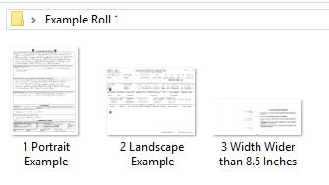
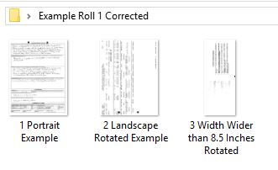

Transferring Files for Conversion
Agencies should contact the IARA Imaging Lab to discuss the best way to transfer digital files. Best practice is to use a secure File Sharing Program. Secure cloud sharing programs such as Office 365 and Syncplicity are also a preferable option. If an agency must send a CD or external drive it is suggested that they are encrypted with a password.

