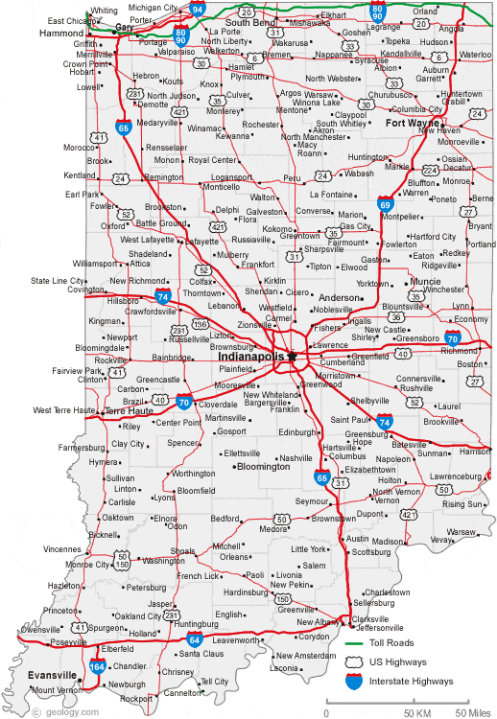 04

**B**

**H**

**E**

**N**

**F**

**M**

**L**

**J**

**K**

**I**

**G**

**A**

State POC – 800-237-2850 x 77097

Evansville Site 620180 **N**

Phone 800-237-2850 x 87311

3300 Division St, Evansville, IN 47715

Walk-in M - F 0800-1500, Lunch 1130-1230

**C**

**D**

Crane Naval Station Site 170589

Phone 813-854-1536 **M**

300 Highway 361, Crane, IN 47522

Appointment Only M - F, 0730-1500

Terre Haute Site 108384

Phone 812-877-5594 **J**

Hulman Air Field

Appointment only T & TH, 0900-1600



South Bend Site 102846

Phone 800-237-2850 x 88808 **B**

1901 S Kemble Ave, South Bend, IN 46613

M-F walk-in 0800-1200, Appointment 1300-1500

Bloomington Site 620187

Phone 800-237-2850 x 87414 **L**

3380 S Walnut Ave, Bloomington, IN 47401

Appointment only M-F, 0800-1500

Camp Atterbury Site 154162, 620178

Phone 800-237-2850 x 61278 **K**

5th N Street, Bldg. 338 Edinburgh, IN 46214

Appointment M-F 0900-1600

JFHQ, Stout Field Site 150678, 620179

Phone 800-237-2850 x 77183 **I**

2002 S Holt Rd, Indianapolis, IN 46241

Walk-in M - F 0800-1500, Lunch 1200-1300

DFAS Fort Harrison Site 102009

Phone 317-212-4430 **H**

8899 E 56th St, Indianapolis, IN 46216

Appointment Only M - F 0700-1430

Muncie Site 620930

Phone 800-237-2830 x 88603 **G**

401 N Country Club Rd, Muncie, IN 47303

Appointment Only T & TH 0900-1600

Lafayette Site 620420

Phone 800-237-2850 x 87525 **F**

5218 Haggerty Lane, Lafayette, IN 47905

Appointment only M-F 0730-1500

Grissom ARB Site 102411

Phone 765-688-3909 **E**

7207 Grissom Ave Grissom ARB, IN 46971

Appointment only M, W, TH, F 0730-1500

Fort Wayne NG Site 620181

130 W Cook Rd Fort Wayne, IN 46825 **D**

Phone 800-237-2850 x 87265

Appointment only M & W 0800-1500

Fort Wayne AF Site 102405

Phone 260-478-3231 **C**

Fort Wayne International Airport

Appointment only T & TH 0900-1100

Gary Site 620188

Phone 800-237-2850 x 88015 **A**

2501 E 15th Ave, Gary, IN 46402

Walk in M - F 0800-1500, Lunch 1200-1300

