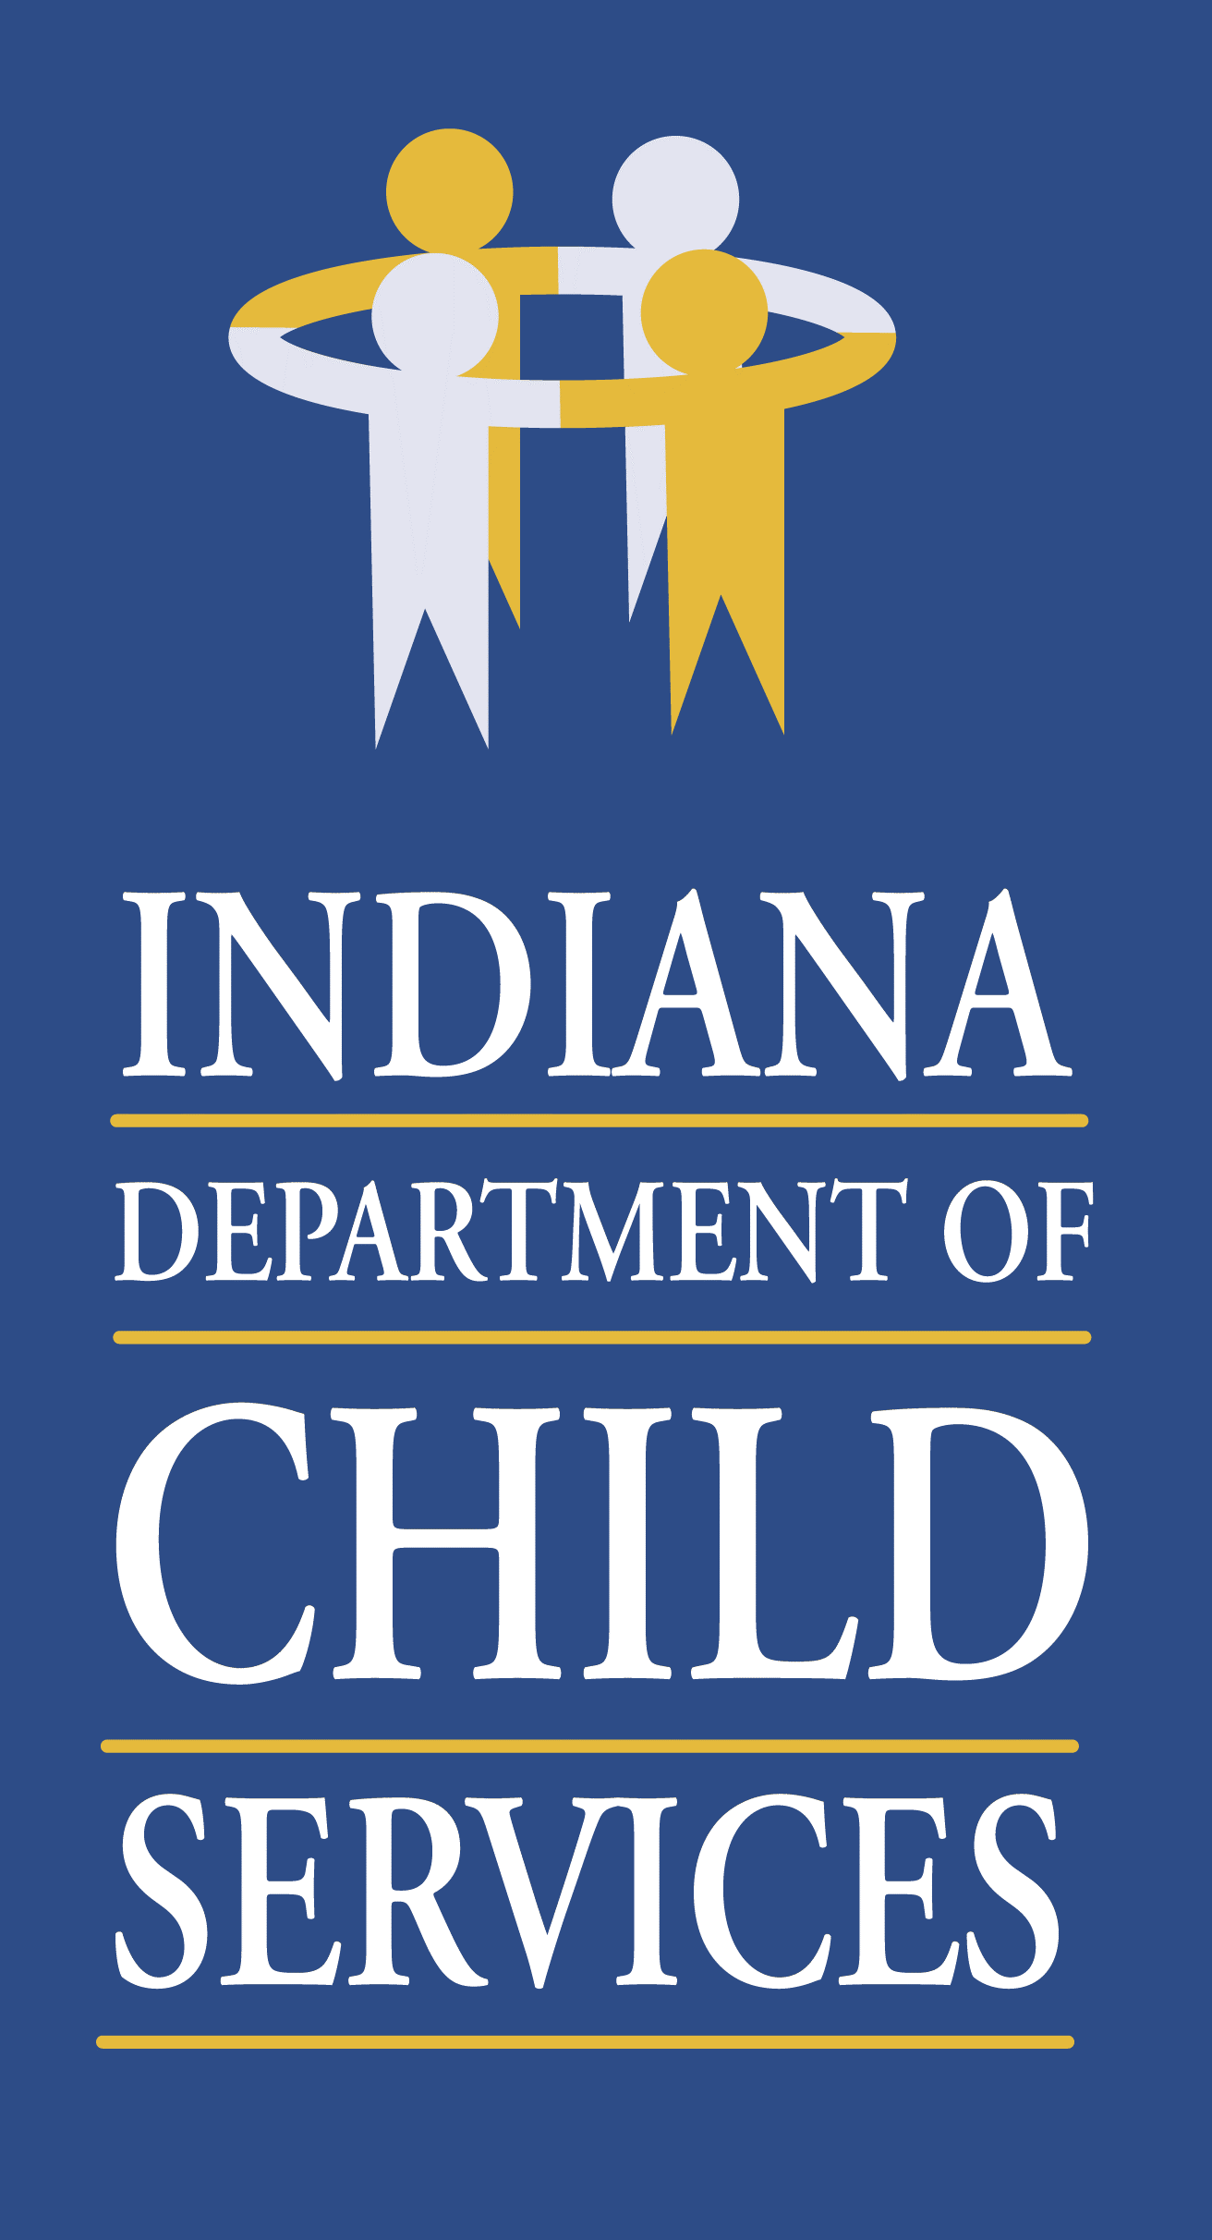
Regional Service Council Meeting Agenda- Region 3
Monday January 10th, 2020 @ 10:00 a.m.
Join Microsoft Teams Meeting
+1 317-552-1674 United States, Indianapolis (Toll)
Conference ID: 240 958 24#

- Welcome/Introduction of Members & Guests: Kathryn Stephenson, Regional Manager
- Review/Approval of Previous Meeting Minutes
- Community Partners Update: Christy Roberts, Program Administrator
- Service Update: Dion Smith, Regional Service Coordinator
- Regional Budget Update: Joni Tusing, Regional Financial Manager
- County Updates: Local Office DCS Directors
- Elkhart – Tamara Perkey
- Kosciusko – Lindsay Castro
- Marshall – Amanda Egger
- St. Joseph – Teresa Zornig
Other Business:
Biennial Regional Services Strategic Plan

- Adjourn

